**Lab Assignment No. 2 B**

**Title: Create Docker Container Environment (NVIDIA Docker or any other).**

1. Create **Dockerfile**

**Dockerfile**

FROM node:alpine

COPY . /docker1

CMD node /docker1/app.js

1. Create **app.js**

**app.js**

console.log('Dhananjay')

console.log('35036')

1. Run the command to build an image from the docker file

**docker build -t docker1 .**

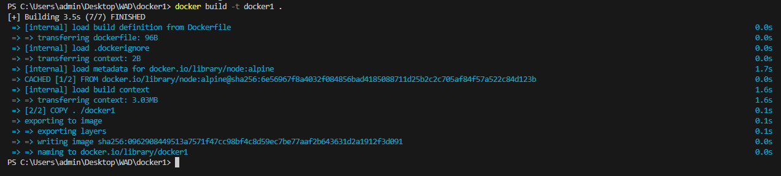

1. Run the command to see the all images

**docker images**



